**Infrastructure as Code**

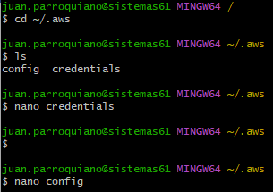

## Step 1: Create a Key Pair for EC2

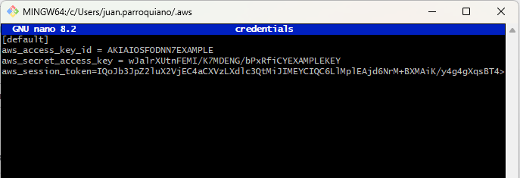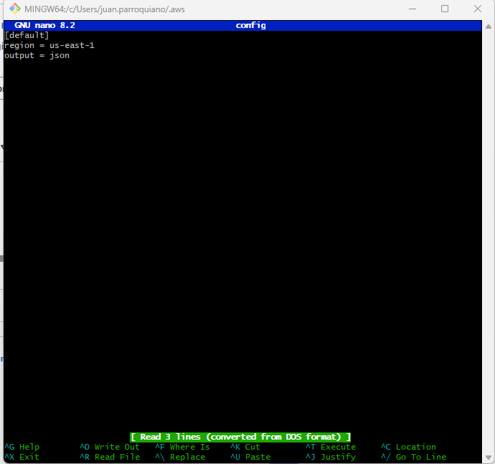

aws ec2 create-key-pair --key-name MyKeyPair --query 'KeyMaterial' --output text > MyKeyPair.pem

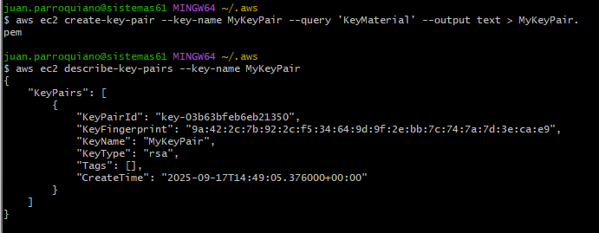

## Step 2: Create a Security Group

First, check for VPCs configured in your account.

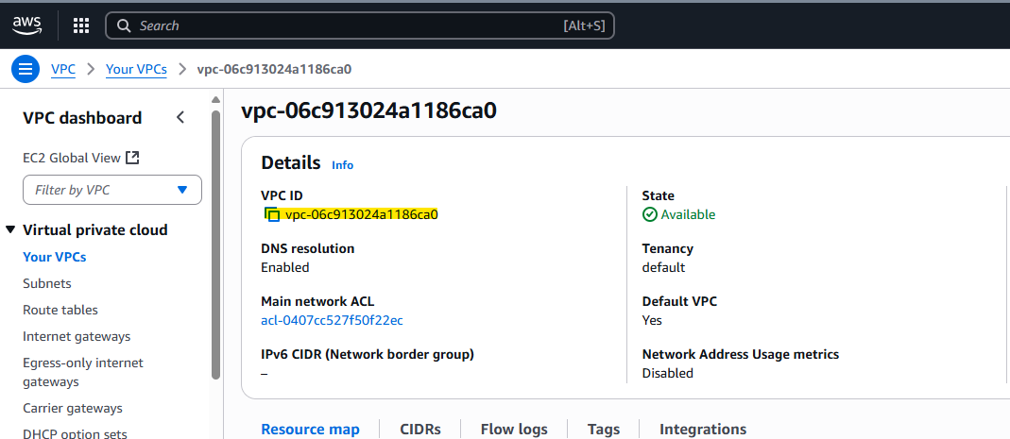

aws ec2 create-security-group --group-name my-sg-cli --description "My security group" --vpc-id vpc-06c913024a1186ca0

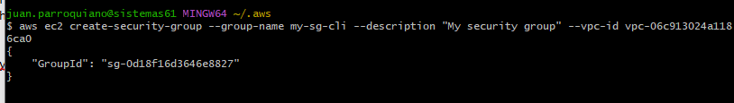

List security groups:

aws ec2 describe-security-groups --group-ids sg-0d18f16d3646e8827

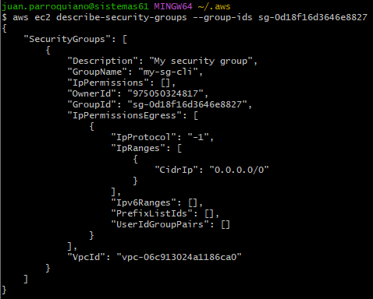

### Add Ingress Rules

Check your public IP address (optional for restricted access):

curl <https://checkip.amazonaws.com>

45.239.88.82



Allow RDP (port 3389):

aws ec2 authorize-security-group-ingress --group-id sg-0d18f16d3646e8827 --protocol tcp --port 3389 --cidr 0.0.0.0/0

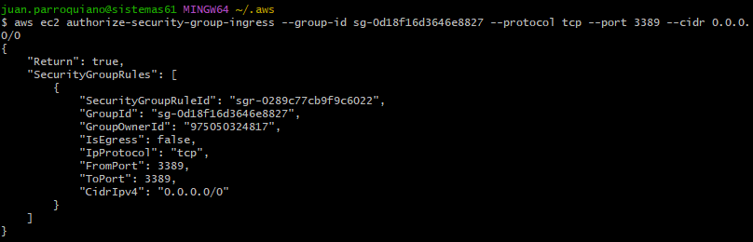

Allow SSH (port 22):

aws ec2 authorize-security-group-ingress --group-id sg-0d18f16d3646e8827 --protocol tcp --port 22 --cidr 0.0.0.0/0

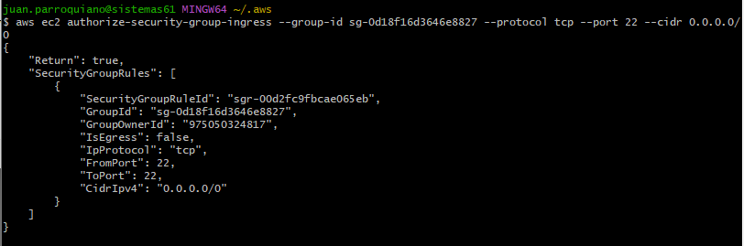

## Step 3: Create the Instance

Before creating the instance, ensure you have a subnet configured.

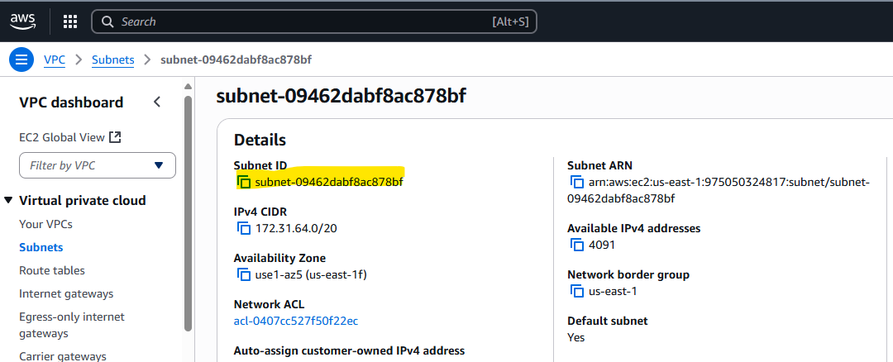Run the following command to launch a **t2.micro** instance:

aws ec2 run-instances --image-id ami-032930428bf1abbff --count 1 --instance-type t2.micro --key-name MyKeyPair --security-group-ids sg-0d18f16d3646e8827 --subnet-id subnet-09462dabf8ac878bf

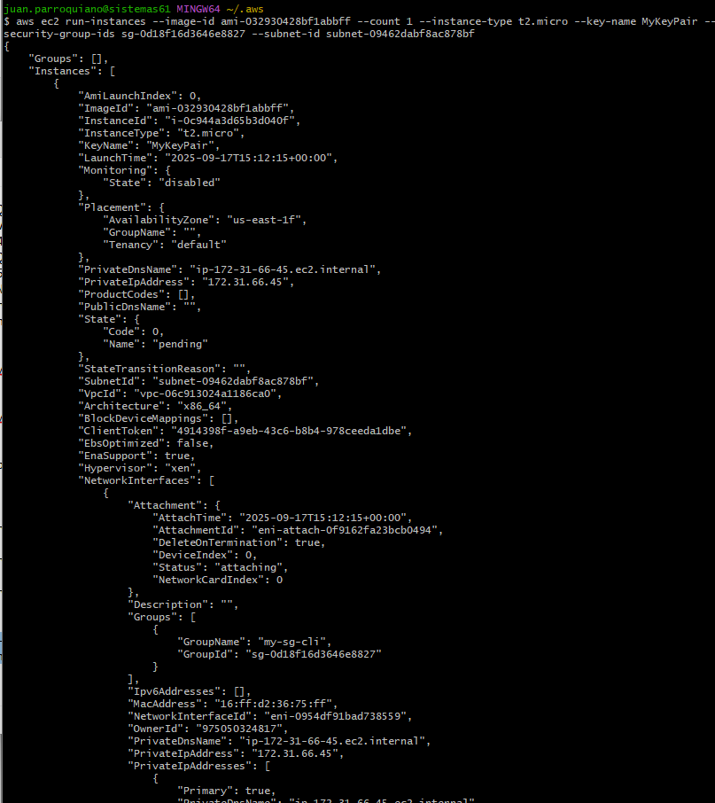

## Step 4: Connect to the Instance

ssh -i "MyKeyPair.pem" [ec2-user@ec2-3-238-97-242.compute-1.amazonaws.com](mailto:ec2-user@ec2-3-238-97-242.compute-1.amazonaws.com)

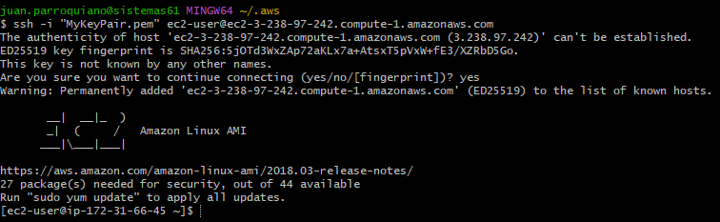

## Step 5: List Your Instances

aws ec2 describe-instances --filters "Name=instance-type,Values=t2.micro" --query "Reservations[].Instances[].InstanceId"

## 

## Step 6: Clean Up

Delete the key pair:

aws ec2 delete-key-pair --key-name MyKeyPair

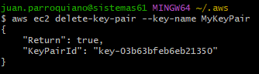

Delete the security group:

aws ec2 delete-security-group --group-id sg-0d18f16d3646e8827

Terminate the instance:

aws ec2 terminate-instances --instance-ids i-07d0ddb36ea3e65a4

